**CHAPTER 1**

**INTRODUCTION**

**1.1NETWORK SECURITY**

Network security is the security provided to a network from unauthorized access and risks. It is the duty of network administrators to adopt preventive measures to protect their networks from potential security threats. Computer networks that are involved in regular transactions and communication within the government, individuals, or business require security. The most common and simp le way of protecting a network resource is by assigning it a unique name and a corresponding password.

A firewall is a network security system that manages and regulates the network traffic based on some protocols. A firewall establishes a barrier between a trusted internal network and the internel. Firewalls exist both as software that run on a hardware and as hardware appliances. Firewalls that are hardware-based also provide other functions like acting as a DHCP server for that network. Most personal computers use software-based firewalls to secure data from threats from the internet.

Many routers that pass data between networks contain firewall components and conversely, many firewalls can perform basic routing functions. Firewalls are commonly used in private networks or intranets to prevent unauthorized access from the internet. Every message entering or leaving the intranet goes through the firewall to be examined for security measures. An ideal firewall configuration consists of both hardware and software based devices. A firewall also helps in providing remote access to a private network through secure authentication certificates and logins.

* 1. **SECURE MICRO PAYMENTS USING PHYSICAL UNCLONABLE**

**FUNCTION**

One important aspect of "micropayments" is that the definition varies with the audience. This page lists a variety of systems claiming to be "Micropayments". All of them are capable of handling arbitrarily small amounts of money. This was never a real problem; the problem is keeping the cost for the individual transaction low. This imposes requirements on speed and cost of processing of the payments: delivery occurs nearly instantaneously on the Internet, and often in arbitrarily small pieces. On the other hand, the bottleneck in sales of tangible goods, handling and shipping, sets a lower bound particularly for costs to remain economical.FRoDO is a secure off-line micro-payment solution that is resilient to PoS data breaches. Our solution improves over up to date approaches in terms of flexibility and security. To the best of our knowledge, FRoDO is the first solution that can provide secure fully off-line payments while being resilient to all currently known PoS breaches. Secure off-line micro-payment approach using multiple physical unclonable functions (PUFs).

FRoDO features an identity element to authenticate the customer, and a coin element where coins are not locally stored, but are computed on-the fly when needed. The communication protocol used for the payment transaction does not directly read customer coins. Instead, the vendor only communicates with the identity element in order to identify the user. This simplification alleviates the communication burden with the coin element that affected our previous approach.

The main benefit is a simpler, faster, and more secure interaction between the involved actors/entities. Among other properties, this two-steps protocol allows the bank or the coin element issuer to design digital coins to be read only by a certain identity element, i.e., by a specific user. Furthermore, the identity element used to improve the security of the users can also be used to thwart malicious users.

To the best of our knowledge, this is the first solution that can provide secure micropayments while being resilient to all currently known PoS breaches. With the rising importance of intangible (e.g. information) goods in global economies and their instantaneous delivery at negligible cost, "conventional" payment methods tend to be more expensive than the actual product. On the other hand, billing for small portions of a product or service reduces the need of security.

* 1. **PROBLEM STATEMENT AND ANALYSIS**

In recent years, Network Security along with offline micropayment system has found a lot of applications and it’s the major payment. This poses a major security threat via various attacks on the network. Attackers often aim at stealing such customer data by targeting the Point of Sale (for short, PoS) system, i.e. the point at which a retailer first acquires customer data. Modern PoS systems are powerful computers equipped with a card reader and running specialized software. Increasingly often, user devices are leveraged as input to the PoS. In these scenarios, malware that can steal card data as soon as they are read by the device has flourished. Skimmers: In this attack, the customer input device that belongs to the PoS system is replaced with a fake one in order to capture customer’s card data. As an example, input devices can be either physically replaced or directly purchased with vulnerable or misconfigured software. Scrapers: In this attack, a malware is installed within the PoS system in order to steal customer’s card data. As an example, cybercriminals can infect the system using phishing attacks.

**CHAPTER 2**

**LITERATURE SURVEY**

* 1. **FORCE FULLY OFF-LINE SECURE CREDITS FOR MOBILE**

**MICRO PAYMENTS**

Payment schemes based on mobile devices are expected to supersede traditional electronic payment approaches in the next few years. However, current solutions are limited in that protocols require at least one of the two parties to be on-line, i.e. connected either to a trusted third party or to a shared database. Indeed, in cases where customer and vendor are persistently or intermittently disconnected from the network, any on-line payment is not possible.This paper introduces FORCE, a novel mobile micro payment approach where all involved parties can be fully off-line. Our solution improves over state-of-the-art approaches in terms of payment flexibility and security. In fact, FORCE relies solely on local data to perform the requested operations.at catching the topological impact introduced by the wormhole.

**2.2 BUILDING ROBUST M-COMMERCE PAYMENT SYSTEM ON**

**OFFLINE WIRELESS NETWORK**

Mobile commerce is one of the upcoming research area with focus on mobile payment systems. Unfortunately, the current payment systems is directly dependent on fixed infrastructure of network (cellular network), which fails to facilitate optimal level of security for the payment system. The proposed system highlights a novel approach for building secure, scalable, and flexible e-payment systems in the distributed scenario of wireless ad hoc network in offline mode of communication for enhanced security on transaction and payment process. The proposed system uses Simple Public Key Infrastructure for providing the security in payment processes.

* 1. **EXTRACTING SECRET KEYS FROM INTEGRATED CIRCUITS**

Modern cryptographic protocols are based on the premise that only authorized participants can obtain secret keys and access to information systems. However, various kinds of tampering methods have been devised to extract secret keys from conditional access systems such as smartcards and ATMs. Arbiter-based physical unclonable functions (PUFs) exploit the statistical delay variation of wires and transistors across integrated circuits (ICs) in manufacturing processes to build unclonable secret keys.We fabricated arbiter-based PUFs in custom silicon and investigated the identification capability, reliability, and security of this scheme. Experimental results and theoretical studies show that a sufficient amount of inter-chip variation exists to enable each IC to be identified securely and reliably over a practical range of environmental variations such as temperature and power supply voltage. We show that arbiter-based PUFs are realizable and well suited to build, for example, key-cards that need to be resistant to physical attacks.

# FORENSIC ANALYSIS OF SKIMMING DEVICES FOR CREDIT FRAUD DETECTION

# Magnetic stripe cards are widely used by many different organizations to provide both convenience and security. These types of cards are often relied on identification and personal authentication. For instance, skimming takes advantages of the fact that the digital content of a magnetic stripe card can be copied with perfection. The goal of this research paper is to introduce the range of devices available for manipulating magnetic stripe card data, demonstrate the ease by which magnetic stripe cards are often fraudulently cloned and analyze how such devices can be processed in a forensically sound manner.

# DESIGN OF SECURITY ENHANCED TPM CHIP AGAINST INVASIVE

# PHYSICAL ATTACKS

A TPM (Trusted Platform Module) is hardware based secure device that is very strong against software-based attacks; however, the keys inside a TPM can be extracted by invasive physical attacks such as memory attacks and bus probing attacks. To protect the keys from these threats, we propose a new TPM architecture based on a Physical Unclonable Function.

* 1. **USING 3G NETWORK COMPONENTS TO ENABLE NFC MOBILE**

**TRANSACTIONS AND AUTHENTICATION**

The increasing technical capabilities of mobile phones have resulted in several m-payment methods being proposed. M-payment applications are being developed for both online and in-store purchases. Near Field Communication (NFC) technology has the potential to greatly impact the way mobile devices are used. NFC is a short range wireless communication interface that allows for the integration of a mobile device in existing contactless application infrastructure, such as using a mobile phone to pay at Point-of-Sale (POS). It is important to provide a simple method for implementing m-payment systems that offer both reasonable security protection as well as ease of use for the user. We propose a system that combines the existing 3G cryptographic primitives and algorithms, in addition to the identification and authentication capabilities of the USIM, with NFC technology to implement a m-payment system. Such a system could easily be integrated into current 3G infrastructure and provide improved scalability and ubiquity for m-payment services. Our proposed scheme focuses on a conventional in store payment environment, with mutual authentication between entities and a subsequent trustworthy transaction being achieved through 3G and USIM security services.

**CHAPTER 3**

**SYSTEM ANALYSIS**

System analysis is a problem solving technique that decomposes a system into its component pieces for the purpose of the studying how well those component parts work and interact to accomplish their purpose. It is the process of studying a procedure or business in order to identify its goals and purposes and create systems and procedures that will achieve them in an efficient way. It is the process of analyzing the already existing system and its features and identifying the drawbacks and areas where improvements can be made in the proposed system to make the effort worthwhile. The feasibility check is performed to check whether developing the system is viable or not. This is the phase where the ideas for the proposed system are formulated for further developments and analyzed whether implementing them will be possible or not.

* 1. **EXISTING SYSTEM**

PoS systems act as gateways and require some sort of network connection in order to contact external credit card processors. PoS devices may be remotely managed over these internal networks. Mobile payment solutions proposed so far can be classified as fully on-line, semi off-line, weak off-line or fully off-line. The work is called FORCE, that FORCE provided a weak prevention strategy based on data obfuscation and did not address the most relevant attacks aimed at threatening customer sensitive data, thus being vulnerable to many advanced attack techniques

* 1. **LIMITATIONS OF EXISTING SYSTEM**
* Off-line scenarios are harder to protect, customer data is kept within the PoS for much longer time, thus being more exposed to attackers.
* Skimmers: in this attack, the customer input device that belongs to the PoS system is replaced with a fake one in order to capture customer’s card data.
* The main issue with a fully off-line approach is the difficulty of checking the trustworthiness of a transaction without a trusted third party.
* External parties or shared databases can be quite difficult with no available connection.
* This technique didn’t notice discussion on real world attacks such as skimmers, scrapers and data vulnerabilities is missing.

**3.3 PROPOSED SYSTEM**

FRoDO is the first solution that neither requires trusted third parties, nor bank accounts, nor trusted devices. Digital coins used in FRoDO are just a digital version of real cash and, as such, they are not linked to anybody else than the holder of both the identity and the coin element. FRoDO features an identity element to authenticate the customer, and a coin element where coins are not locally stored, but are computed on-the fly when needed. Payment transaction does not directly read customer coins.

The vendor only communicates with the identity element in order to identify the user. The main benefit is a simpler, faster, and more secure interaction between the involved actors/entities. The identity element used to improve the security of the users. This is the first solution that can provide secure fully off-line payments while being resilient to all currently known PoS breaches.

* 1. **ADVANTAGES OF PROPOSED SYSTEM**
* Transaction not required any networks.
* Transactions didn’t affect due to network problems.
* Perform Payment without Trusted Third Party.
* More benefits for feature developing too many applications because it’s using standard coin from card issuer/Banker.
* To gives secure micropayment transaction from real world attacks such as skimmers, scrapers and data vulnerabilities Payment.

**SYSTEM REQUIREMENTS**

**3.5.1 HARDWARE REQUIREMENTS**

* System : Pentium Dual Core.
* Hard Disk : 120 GB.
* Monitor : 15’’ LED
* Input Devices : Keyboard, Mouse
* RAM : 1GB.

**3.5.2 SOFTWARE REQUIREMENTS**

* Operating system : Windows Family
* Coding Language : JAVA/J2EE
* Tool : Eclipse
* Database : MYSQL

**CHAPTER 4**

**SYSTEM DESIGN**

**4.1 SYSTEM ARCHITECTURE**

User is registered first before login. User and Vendor are waiting for activation. Customer gives the payment request after Activation. Users are activated by Frodo. Gives bank name, permanent card number and its pin number to registration. User Details are Stored in Database. Vendor is registered first before login. Vendor Details are Stored in Database. Vendor is waiting for activation. Vendors get transaction after activation. Users and Vendors are activated by Frodo. Gives bank name, Branch and password to registration. User Details are Stored in Database.

Frodo view the user who gives request to activation and Frodo activate the user. Identity element is generating private key to the user and coin element generate binary code for user account number into binary code. This two-step makes Payment more secure. Key Generator used generate the private key of the identity element and symmetric and asymmetric cryptographic algorithms applied to data received in input and sent as output by the identity element. After activation user login into account to gives payment request. Enter the required payment and Check the availability of payment for customer requirement. Required amount encrypted using key and after payment request goes to PUF verification. After PUF verification Payment transaction will success.

Heart of FRoDO proposal lies a read-once strong physical unclonable function. PUF check vendors details involved in payment and activate the vendors. In payment verification PUF check both Identity and Coin Element. After verification payment decrypted using public key and the payment transaction completed successfully and whole transaction will be secure. Finally receives the Private Response, the last step only requires the coin just read to be validated. Then, the whole payment transaction can be authorized and committed.

 **SYSYTEM ARCITECTURE DIAGRAM**

**MODULES**

**4.2 MODULE DESIGN**

* Client Module
* Vendor Module
* Key Generation
* Payment Request
* PUF Process

**4.2.1 Client Module:**

User is registered first before login. User and Vendor are waiting for activation. Customer gives the payment request after Activation. Users are activated by Frodo. Gives bank name, permanent card number and its pin number to registration. User Details are Stored in Database.



**4.2.2 Vendor Module:**

Vendor is registered first before login. Vendor Details are Stored in Database. Vendor is waiting for activation. Vendors get transaction after activation. Users and Vendors are activated by Frodo. Gives bank name, Branch and password to registration. User Details are Stored in Database.



**4.2.3 Key Generation:**

Frodo view the user who gives request to activation and Frodo activate the user. Identity element is generating private key to the user and coin element generate binary code for user account number into binary code. This two-step makes Payment more secure. Key Generator used generate the private key of the identity element and symmetric and asymmetric cryptographic algorithms applied to data received in input and sent as output by the identity element.



**4.2.4 Payment Request:**

After activation user login into account to gives payment request. Enter the required payment and Check the availability of payment for customer requirement. Required amount encrypted using key and after payment request goes to PUF verification. After PUF verification Payment transaction will success.



**4.2.5 PUF Process:**

Heart of FRoDO proposal lies a read-once strong physical unclonable function. PUF check vendors details involved in payment and activate the vendors. In payment verification PUF check both Identity and Coin Element. After verification payment decrypted using public key and the payment transaction completed successfully and whole transaction will be secure. Finally receives the Private Response, the last step only requires the coin just read to be validated. Then, the whole payment transaction can be authorized and committed.



**4.3 DATA FLOW DIAGRAM**

**4.3.1 Level 0**



**Figure 4.3.1: Level 0 DFD**

**4.3.2 Level 1**



**Figure 4.3.2: Level 1 DFD4.3.3 Level 2**



**Figure 4.3.3: Level 2 DFD**

**4.3.4 Level 3**



**Figure 4.3.3: Level 2 DFD**

**4.4 UML DIAGRAM**

**4.4.1USE CASE DIAGRAM**

A use case diagram at its simplest is a representation of a user's interaction with the system and depicting the specifications of a use case. A use case diagram can portray the different types of users of a system and the various ways that they interact with the system. This type of diagram is typically used in conjunction with textual use case and will often be accompanied by other types of diagrams as well.

**Figure 4.4.1: Use Case Diagram**

**4.4.2 ACTIVITY DIAGRAM**

Activity diagrams are graphical representations of workflows of stepwise activities and actions with support for choice, iteration and concurrency. In the Unified Modeling Language, activity diagrams are intended to model both computational and organizational processes (i.e, workflows). Activity diagrams show the overall flow of control. Activity diagrams are constructed from a limited number of shapes, connected with arrows. The most important shape types:

* rounded rectangles represent actions;
* diamonds represent decisions;
* bars represent the start (split) or end (join) of concurrent activities;
* a black circle represents the start (initial state) of the workflow;
* an encircled black circle represents the end (final state).

Arrows run from the start towards the end and represent the order in which activities happen.



**Figure 4.4.2: Activity Diagram**

**4.4.3 SEQUENCE DIAGRAM**

A sequence diagram in Unified Modeling Language (UML) is a kind of interaction diagram that shows how processes operate with one another and in what order. It is a construct of a Message Sequence Chart. Sequence diagrams are sometimes called Event-trace diagrams, event scenarios, and timing diagrams. A sequence diagram shows, as parallel vertical lines (lifelines), different processes or objects that live simultaneously, and, as horizontal arrows, the messages exchanged between them, in the order in which they occur. This allows the specification of simple runtime scenarios in a graphical manner.



**Figure 4.4.3: Sequence diagram**

**4.4.4 COLLABORATION DIAGRAM**

Collaboration diagrams belong to a group of UML diagrams called Interaction Diagrams. Collaboration diagrams, like Sequence Diagrams, show how objects interact over the course of time. However, instead of showing the sequence of events by the layout on the diagram, collaboration diagrams show the sequence by numbering the messages on the diagram. This makes it easier to show how the objects are linked together, but harder to see the sequence at a glance.



**Figure 4.4.4: Collaboration diagram**

**CHAPTER 5**

**IMPLEMENTATION**

Implementation is the most crucial stage in achieving a successful system and giving the user’s confidence that the new system is workable and effective. Implementation of a modified application is to replace an existing one. This type of conversation is relatively easy to handle, provided there are no major changes in the system.Each program is tested individually at the time of development using the data and has verified that this program linked together in the way specified in the program specifications, the computer system and its environment is tested to the satisfaction of the user.

And so the system is going to be implemented very soon. The simple operating procedure is included so that the user can understand the different function clearly and quickly.Initially as a first step the executable form of the application is to be created and loaded in the common server machine which is accessible to the entire user and the server is to be connected to a network.

The final stage is to document the entire system which provides components and the operating procedures of the system.Implementation is the stage of project, when the theoretical design is turned out into a working system. Thus it can be considered to be the most critical stage in achieving a successful new system and in giving the user, confidence that the new system will work and be effective.

**CHAPTER 6**

**SYSTEM TESTING**

**6.1 PROCESS**

The purpose of testing is to discover errors. Testing is the process of trying to discover every conceivable fault or weakness in a work product. It provides a way to check the functionality of components, sub assemblies, assemblies and/or a finished product It is the process of exercising software with the intent of ensuring that the Software system meets its requirements and user expectations and does not fail in an unacceptable manner. There are various types of test. Each test type addresses a specific testing requirement.

**6.2TYPES OF TESTS**

**6.2.1UNIT TESTING**

Unit testing involves the design of test cases that validate that the internal program logic is functioning properly, and that program input produces valid outputs. All decision branches and internal code flow should be validated. It is the testing of individual software units of the application .it is done after the completion of an individual unit before integration. This is a structural testing, that relies on knowledge of its construction and is invasive. Unit tests perform basic tests at component level and test a specific business process, application, and/or system configuration.

**6.3.2INTEGRATION TESTING**

Integration tests are designed to test integrated software components to determine if they actually run as one program. Testing is event driven and is more concerned with the basic outcome of screens or fields. Integration tests demonstrate that although the components were individually satisfaction, as shown by successfully unit testing, the combination of components is correct and consistent. Integration testing is specifically aimed at exposing the problems that arise from the combination of components.

**6.2.3FUNCTIONAL TESTING**

Functional tests provide systematic demonstrations that functions tested are available as specified by the business and technical requirements, system documentation and user manuals.

Functional testing is centered on the following items:

Valid Input : identified classes of valid input must be accepted.

Invalid Input : identified classes of invalid input must be rejected.

Functions : identified functions must be exercised.

Output : identified classes of application outputs must be exercised.

Systems/Procedures : interfacing systems or procedures must be invoked.

In addition, systematic coverage pertaining to identify Business process flows; data fields, predefined processes, and successive processes must be considered for testing. Before functional testing is complete, additional tests are identified and the effective value of current tests is determined.

**6.2.4 SYSTEM TESTING**

System testing ensures that the entire integrated software system meets requirements. It tests a configuration to ensure known and predictable results. An example of system testing is the configuration oriented system integration test. System testing is based on process descriptions and flows, emphasizing pre-driven process links and integration points.

**6.2.5 WHITE BOX TESTING**

White Box Testing is a testing in which the software tester has knowledge of the inner workings, structure and language of the software, or at least its purpose. It is used to test areas that cannot be reached from a black box level.

**6.2.6 BLACK BOX TESTING**

Black Box Testing is testing the software without any knowledge of the inner workings, structure or language of the module being tested. Black box tests, as most other kinds of tests, must be written from a definitive source document, such as specification or requirements document, such as specification or requirements document. It is a testing in which the software under test is treated, as a black box .you cannot “see” into it .

**6.2.7Test Results**

All the test cases mentioned above passed successfully. No defects encountered.

**6.3TEST CASES**

**6.3.1TESTING OBJECTIVE**

Testing is the process of trying to discover every conceivable fault or weakness in a work product. It provides a way to check the functionality of components, sub assemblies, assemblies and/or a finished product.

**Test objectives**

* All field entries must work properly.
* Pages must be activated from the identified link.
* The entry screen, messages and responses must not be delayed.
* Features to be tested
* Verify that the entries are of the correct format
* No duplicate entries should be allowed
* All links should take the user to the correct page.

**Case1:** In Case1 we have test the performance of Network and Topology invention module, by giving various inputs and then compare with our expected output.

**Case2:** In Case2, we have test the performance of Spam zombies’ detection machine creation module, by giving various inputs and then compare with our expected output.

**Case3:** In Case3, we have test performance of spot detection and analysis module, by giving various inputs and then compare with our expected output.

**Case4:** In Case4, we have test the performance of Spam count based detection analysis module, by giving various inputs and then compare with our expected output.

**Case5:** In Case5, we have test the performance of Spam percentage based detection analysis module, by giving various inputs and then compare with our expected output.

**Case6:** In Case6, we have test the performance of Evaluation of dynamic IP address module, by giving various inputs and then compare with our expected output.

**CHAPTER 7**

**ABOUT THE SOFTWARE LANGUAGE**

## 7.1 JAVA TECHNOLOGY

Java technology is both a programming language and a platform.

### 7.2 THE JAVA PROGRAMMING LANGUAGE

The Java programming language is a high-level language that can be characterized by all of the following buzzwords:

* + - Simple
    - Architecture neutral
    - Object oriented
    - Portable
* Distributed
* High performance
* Interpreted
* Multithreaded
* Robust
* Dynamic
* Secure

With most programming languages, you either compile or interpret a program so that you can run it on your computer. The Java programming language is unusual in that a program is both compiled and interpreted. With the compiler, first you translate a program into an intermediate language called Java byte codes —the platform-independent codes interpreted by the interpreter on the Java platform. The interpreter parses and runs each Java byte code instruction on the computer. Compilation happens just once; interpretation occurs each time the program is executed. The following figure illustrates how this works.

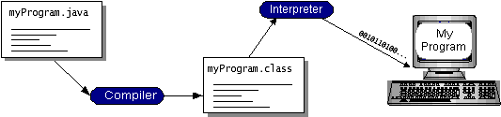

**FIGURE 2- WORKING OF JAVA**

You can think of Java byte codes as the machine code instructions for the Java Virtual Machine (Java VM). Every Java interpreter, whether it’s a development tool or a Web browser that can run applets, is an implementation of the Java VM. Java byte codes help make “write once, run anywhere” possible. You can compile your program into byte codes on any platform that has a Java compiler. The byte codes can then be run on any implementation of the Java VM. That means that as long as a computer has a Java VM, the same program written in the Java programming language can run on Windows 2000, a Solaris workstation, or on an iMac.

### 7.3 JAVA PLATFORM

A platformis the hardware or software environment in which a program runs. We’ve already mentioned some of the most popular platforms like Windows 2000, Linux, Solaris, and Mac OS. Most platforms can be described as a combination of the operating system and hardware. The Java platform differs from most other platforms in that it’s a software-only platform that runs on top of other hardware-based platforms.

The Java platform has two components:

* The Java Virtual Machine (Java VM)
* The Java Application Programming Interface (Java API)

You’ve already been introduced to the Java VM. It’s the base for the Java platform and is ported onto various hardware-based platforms.

The Java API is a large collection of ready-made software components that provide many useful capabilities, such as graphical user interface (GUI) widgets. The Java API is grouped into libraries of related classes and interfaces; these libraries are known as packages. The next section, What Can Java Technology Do?, highlights what functionality some of the packages in the Java API provide.

The following figure depicts a program that’s running on the Java platform. As the figure shows, the Java API and the virtual machine insulate the program from the hardware.

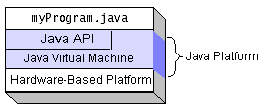

**FIGURE 3- THE JAVA PLATFORM**

Native code is code that after you compile it, the compiled code runs on a specific hardware platform. As a platform-independent environment, the Java platform can be a bit slower than native code. However, smart compilers, well-tuned interpreters, and just-in-time byte code compilers can bring performance close to that of native code without threatening portability.

* **Security**: Both low level and high level, including electronic signatures, public and private key management, access control, and certificates.
* **Software components**: Known as JavaBeans TM, can plug into existing component architectures.
* **Object serialization**: Allows lightweight persistence and communication via Remote Method Invocation (RMI).
* **Java Database Connectivity (JDBCTM)**: Provides uniform access to a wide range of relational databases.

The Java platform also has APIs for 2D and 3D graphics, accessibility, servers, collaboration, telephony, speech, animation, and more. The following figure depicts what is included in the Java 2 SDK.

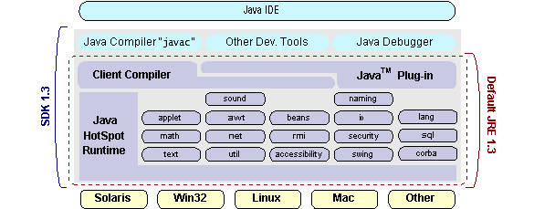

**FIGURE 4 – JAVA 2 SDK**

**URL**

The Web is a loose collection of higher-level protocols and file formats, all unified in a web browser. One of the most important aspects of the Web is that Tim Berners-Lee devised a saleable way to locate all of the resources of the Net. The Uniform Resource Locator (URL) is used to name anything and everything reliably.

The URL provides a reasonably intelligible form to uniquely identify or address information on the Internet. URLs are ubiquitous; every browser uses them to identify information on the Web. Within Java’s network class library, the URL class provides a simple, concise API to access information across the Internet using URLs.

### 7.4 ODBC

Microsoft Open Database Connectivity (ODBC) is a standard programming interface for application developers and database systems providers. Before ODBC became a *de facto* standard for Windows programs to interface with database systems, programmers had to use proprietary languages for each database they wanted to connect to. Now, ODBC has made the choice of the database system almost irrelevant from a coding perspective, which is as it should be. Application developers have much more important things to worry about than the syntax that is needed to port their program from one database to another when business needs suddenly change.

Through the ODBC Administrator in Control Panel, you can specify the particular database that is associated with a data source that an ODBC application program is written to use. Think of an ODBC data source as a door with a name on it. Each door will lead you to a particular database. For example, the data source named Sales Figures might be a SQL Server database, whereas the Accounts Payable data source could refer to an Access database. The physical database referred to by a data source can reside anywhere on the LAN.

. Maybe not, but the compiler (or ODBC) gives you the opportunity to write cleaner programs, which means you finish sooner. Meanwhile, computers get faster every year.

**7.5 JDBC**

In an effort to set an independent database standard API for Java, Sun Microsystems developed Java Database Connectivity, or JDBC. JDBC offers a generic SQL database access mechanism that provides a consistent interface to a variety of RDBMSs. This consistent interface is achieved through the use of “plug-in” database connectivity modules, or drivers.

To gain a wider acceptance of JDBC, Sun based JDBC’s framework on ODBC. As you discovered earlier in this chapter, ODBC has widespread support on a variety of platforms. Basing JDBC on ODBC will allow vendors to bring JDBC drivers to market much faster than developing a completely new connectivity solution.

JDBC was announced in March of 1996. It was released for a 90 day public review that ended June 8, 1996. Because of user input, the final JDBC v1.0 specification was released soon after.The remainder of this section will cover enough information about JDBC for you to know what it is about and how to use it effectively. This is by no means a complete overview of JDBC.

### 7.5.1 JDBC Goals

Few software packages are designed without goals in mind. JDBC is one that, because of its many goals, drove the development of the API. These goals, in conjunction with early reviewer feedback, have finalized the JDBC class library into a solid framework for building database applications in Java. The goals that were set for JDBC are important. They will give you some insight as to why certain classes and functionalities behave the way they do. The eight design goals for JDBC are as follows:

1. **SQL Level API**

The designers felt that their main goal was to define a SQL interface for Java. Although not the lowest database interface level possible, it is at a low enough level for higher-level tools and APIs to be created. Conversely, it is at a high enough level for application programmers to use it confidently. Attaining this goal allows for future tool vendors to “generate” JDBC code and to hide many of JDBC’s complexities from the end user.

1. **SQL Conformance**

SQL syntax varies as you move from database vendor to database vendor. In an effort to support a wide variety of vendors, JDBC will allow any query statement to be passed through it to the underlying database driver. This allows the connectivity module to handle non-standard functionality in a manner that is suitable for its users.

**3. JDBC must be implemental on top of common database interfaces**The JDBC SQL API must “sit” on top of other common SQL level APIs. This goal allows JDBC to use existing ODBC level drivers by the use of a software interface. This interface would translate JDBC calls to ODBC and vice versa.

1. **Provide a Java interface that is consistent with the rest of the Java system**

Because of Java’s acceptance in the user community thus far, the designers feel that they should not stray from the current design of the core Java system.

1. **Keep it simple**

This goal probably appears in all software design goal listings. JDBC is no exception. Sun felt that the design of JDBC should be very simple, allowing for only one method of completing a task per mechanism. Allowing duplicate functionality only serves to confuse the users of the API.

1. **Use strong, static typing wherever possible**

Strong typing allows for more error checking to be done at compile time; also, less error appear at runtime.

1. **Keep the common cases simple**

Because more often than not, the usual SQL calls used by the programmer are simple SELECT’s, INSERT’s, DELETE’s and UPDATE’s, these queries should be simple to perform with JDBC. However, more complex SQL statements should also be possible.

## 7.6 NETWORKING

### 7.6.1 TCP/IP STACK

The TCP/IP stack is shorter than the OSI one:

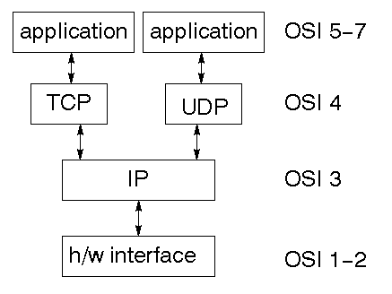

**FIGURE 5 – TCP/IP STACK**

### 7.6.2 IP DATAGRAM

The IP layer provides a connectionless and unreliable delivery system. It considers each datagram independently of the others. Any association between datagram must be supplied by the higher layers. The IP layer supplies a checksum that includes its own header. The header includes the source and destination addresses. The IP layer handles routing through an Internet. It is also responsible for breaking up large datagram into smaller ones for transmission and reassembling them at the other end.

### 7.6.3TCP

TCP supplies logic to give a reliable connection-oriented protocol above IP. It provides a virtual circuit that two processes can use to communicate.

**INTERNET ADDRESS**

In order to use a service, you must be able to find it. The Internet uses address scheme for machines so that they can be located. The address is a 32 bit integer which gives the IP address. This encodes network ID and more addressing. The network ID falls into various classes according to the size of the network address.

### 7.7 NETWORK ADDRESS

### Class A uses 8 bits for the network address with 24 bits left over for other addressing. Class B uses 16 bit network addressing. Class C uses 24 bit network addressing and class D uses all 32.

### 7.7.1 SUBNET ADDRESS

Internally, the UNIX network is divided into sub networks. Building 11 is currently on one sub network and uses 10-bit addressing, allowing 1024 different hosts.

### 7.7.2 HOST ADDRESS

8 bits are finally used for host addresses within our subnet. This places a limit of 256 machines that can be on the subnet.

### 7.7.3 TOTAL ADDRESS

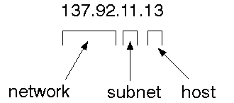

**FIGURE 6 - IP ADDRESSING**

The 32 bit address is usually written as 4 integers separated by dots.

### 7.7.4 PORT ADDRESSES

A service exists on a host, and is identified by its port. This is a 16 bit number. To send a message to a server, you send it to the port for that service of the host that it is running on. This is not location transparency! Certain of these ports are "well known".

**CHAPTER 8**

**CONCLUSION AND FUTURE ENHANCEMENT**

**8.1 CONCLUSION**

FRoDO that is, to the best of our knowledge, the first data-breach-resilient fully offline micro-payment approach. The security analysis shows that FRoDO does not impose trustworthiness assumptions. Further, FRoDO is also the first solution in the literature where no customer device data attacks can be exploited to compromise the system. This has been achieved mainly by leveraging a novel erasable PUF architecture and a novel protocol design. Furthermore, our proposal has been thoroughly discussed and compared against the state of the art.

Finally, some open issues have been identified that are left as future work. In particular, we are investigating the possibility to allow digital change to be spent over multiple off-line transactions while maintaining the same level of security and usability.

**8.2 FUTURE ENHANCEMENT**

In future, we will try to enhance the capability of the AES algorithm to a generate private key and create more security for Electronic payments. Another approach will involve smarter implementation of secure offline transfer of money by using PUF. As for all the real-world payment schemes based on credit, debit and prepaid cards, FRoDO assumes that, in case of bank/coin element issuer private key renewal, a time-window is adequately chosen to let customers decide whether to spend their last coin or to get the current coin element exchanged with a new one. These standard procedures are widely accepted in the real world. As such, no custom key rollover protocol has been designed in FRoDO and we develop to access money without standard coin element.

**APPENDICES**

**APPENDIX-1**

**SOURCE CODE**

package com.midhras.micropay;

import java.io.IOException;

import java.io.PrintWriter;

import java.sql.*;

import javax.servlet.RequestDispatcher;

import javax.servlet.http.HttpServlet;

import javax.servlet.http.HttpServletRequest;

import javax.servlet.http.HttpServletResponse;

import javax.servlet.http.HttpSession;

public class UserRegister extends HttpServlet{

public void doGet(HttpServletRequest req,HttpServletResponse res) throws IOException{

doPost(req, res);

}

public void doPost(HttpServletRequest req,HttpServletResponse res) throws IOException{

String user_name = req.getParameter("user_name");

String password = req.getParameter("password");

String card_number = req.getParameter("card_number");

String date_of_birth = req.getParameter("date_of_birth");

String email = req.getParameter("email");

String phone = req.getParameter("phone");

String bank_name = req.getParameter("bank_name");

String gender = req.getParameter("gender");

int creditAmt = 50000;

String status="N";

String private_key = "0";

String binary_code = "Not Yet Created";

res.setContentType("text/html");

PrintWriter out = res.getWriter();

RequestDispatcher rd;

try

{Connection con=DatabaseConnection.getConnection();

Statement st=con.createStatement();

ResultSet rs=st.executeQuery("Select * from user_details Where user_name='"+user_name+"' and card_number='"+card_number+"'");

if(rs.next())

{ out.println("<script type=\"text/javascript\">");

out.println("alert('Sorry User Name/Account Number already exist!');");

out.println("location='userregister.html';");

out.println("</script>");

}

else{

int i=st.executeUpdate("Insert into user_details Values('"+user_name+"','"+password+"','"+card_number+"','"+date_of_birth+"','"+email+"','"+phone+"','"+bank_name+"','"+gender+"','"+status+"','"+private_key+"','"+binary_code+"','"+creditAmt+"')");

out.println("<script type=\"text/javascript\">");

out.println("alert('User Registration Success...!');");

out.println("location='userlogin.html';");

out.println("</script>");

}}

catch (Exception a)

{System.out.println(a);

}}}

package com.midhras.micropay;

import java.io.IOException;

import java.io.PrintWriter;

import java.sql.Connection;

import java.sql.ResultSet;

import java.sql.Statement;

import javax.servlet.RequestDispatcher;

import javax.servlet.ServletException;

import javax.servlet.http.HttpServlet;

import javax.servlet.http.HttpServletRequest;

import javax.servlet.http.HttpServletResponse;

import javax.servlet.http.HttpSession;

public class UserLogin extends HttpServlet {

private static final long serialVersionUID = 1L;

String name,pass,bank_name,card_number;

protected void doGet(HttpServletRequest request, HttpServletResponse response) throws ServletException, IOException {

// TODO Auto-generated method stub

doPost(request,response);

}

public void doPost(HttpServletRequest req,HttpServletResponse res) throws IOException{

name=req.getParameter("name");

pass=req.getParameter("password");

bank_name=req.getParameter("bank_name");

card_number=req.getParameter("card_number");

res.setContentType("text/html;charset=UTF-8");

PrintWriter out = res.getWriter();

try

{Connection con=DatabaseConnection.getConnection();

Statement st=con.createStatement();

ResultSet rs=st.executeQuery("Select * from user_details Where user_name='"+name+"' and password='"+pass+"' and card_number='"+card_number+"' and bank_name='"+bank_name+"'");

if(rs.next())

{String status = (String)rs.getString(9);

if("N".equals(status)){

out.println("<script type=\"text/javascript\">");

out.println("alert('User is not activated...!');");

out.println("location='userlogin.html';");

out.println("</script>");

}

else{

HttpSession session=req.getSession();

session.setAttribute("user_name",rs.getString(1));

session.setAttribute("password","*********");

session.setAttribute("card_number",rs.getString(3));

session.setAttribute("date_of_birth",rs.getString(4));

session.setAttribute("email",rs.getString(5));

session.setAttribute("phone",rs.getString(6));

session.setAttribute("bank_name",rs.getString(7));

session.setAttribute("gender",rs.getString(8));

out.println("<script type=\"text/javascript\">");

out.println("alert('User Login Success...!');");

out.println("</script>");

RequestDispatcher rd=req.getRequestDispatcher("/userhome.jsp");

rd.include(req, res);

}}

else

{out.println("<script type=\"text/javascript\">");

out.println("alert('Incorrect User Credentials...!');");

out.println("location='userlogin.html';");

out.println("</script>");

}}

catch (Exception a)

{System.out.println(a);

}}}

package com.midhras.micropay;

import java.io.IOException;

import java.io.PrintWriter;

import java.sql.*;

import javax.servlet.RequestDispatcher;

import javax.servlet.http.HttpServlet;

import javax.servlet.http.HttpServletRequest;

import javax.servlet.http.HttpServletResponse;

import javax.servlet.http.HttpSession;

public class VendorRegister extends HttpServlet{

public void doGet(HttpServletRequest req,HttpServletResponse res) throws IOException{

doPost(req,res);

}

public void doPost(HttpServletRequest req,HttpServletResponse res) throws IOException{

String user_name = req.getParameter("user_name");

String password = req.getParameter("password");

String gender = req.getParameter("gender");

String date_of_birth = req.getParameter("date_of_birth");

String email = req.getParameter("email");

String phone = req.getParameter("phone");

String bank_name = req.getParameter("bank_name");

String branch_name = req.getParameter("branch_name");

String status="N";

res.setContentType("text/html");

PrintWriter out = res.getWriter();

RequestDispatcher rd;

try

{Connection con=DatabaseConnection.getConnection();

Statement st=con.createStatement();

ResultSet rs=st.executeQuery("Select * from vendor_details Where user_name='"+user_name+"' ");

if(rs.next())

{out.println("<script type=\"text/javascript\">");

out.println("alert('Sorry Vendor Name already exist!');");

out.println("location='vendorregister.html';");

out.println("</script>");

}

else

{int i=st.executeUpdate("Insert into vendor_details Values('"+user_name+"','"+password+"','"+gender+"','"+date_of_birth+"','"+email+"','"+phone+"','"+bank_name+"','"+branch_name+"','"+status+"')");

out.println("<script type=\"text/javascript\">");

out.println("alert('User Registration Success...!');");

out.println("location='vendorlogin.html';");

out.println("</script>");

}}

catch (Exception a)

{System.out.println(a);

}}}

package com.midhras.micropay;

import java.io.IOException;

import java.io.PrintWriter;

import java.sql.Connection;

import java.sql.ResultSet;

import java.sql.Statement;

import javax.servlet.RequestDispatcher;

import javax.servlet.ServletException;

import javax.servlet.http.HttpServlet;

import javax.servlet.http.HttpServletRequest;

import javax.servlet.http.HttpServletResponse;

import javax.servlet.http.HttpSession;

public class VendorLogin extends HttpServlet {

private static final long serialVersionUID = 1L;

String name,pass,bank_name;

protected void doGet(HttpServletRequest request, HttpServletResponse response) throws ServletException, IOException {

doPost(request,response);

}

public void doPost(HttpServletRequest req,HttpServletResponse res) throws IOException{

name=req.getParameter("name");

pass=req.getParameter("password");

bank_name=req.getParameter("bank_name");

res.setContentType("text/html;charset=UTF-8");

PrintWriter out = res.getWriter();

try

{Connection con=DatabaseConnection.getConnection();

Statement st=con.createStatement();

ResultSet rs=st.executeQuery("Select * from vendor_details Where user_name='"+name+"' and password='"+pass+"' and bank_name='"+bank_name+"'");

if(rs.next())

{ String status = (String)rs.getString(9);

if("N".equals(status)){

out.println("<script type=\"text/javascript\">");

out.println("alert('Vendor is not activated...!');");

out.println("location='vendorlogin.html';");

out.println("</script>");

}

else{

HttpSession session=req.getSession();

session.setAttribute("uName",rs.getString(1));

session.setAttribute("bank_name",rs.getString(7));

out.println("<script type=\"text/javascript\">");

out.println("alert('Vendor Login Success...!');");

out.println("</script>");

RequestDispatcher rd=req.getRequestDispatcher("/vendorhome.jsp");

rd.include(req, res);

} }

else

{out.println("<script type=\"text/javascript\">");

out.println("alert('Incorrect User Credentials...!');");

out.println("location='vendorlogin.html';");

out.println("</script>");

}}

catch (Exception a)

{System.out.println(a);

}}}

package com.midhras.micropay;

import java.io.IOException;

import java.io.PrintWriter;

import java.sql.*;

import java.util.Random;

import javax.servlet.RequestDispatcher;

import javax.servlet.http.HttpServlet;

import javax.servlet.http.HttpServletRequest;

import javax.servlet.http.HttpServletResponse;

import javax.servlet.http.HttpSession;

public class PaymentAmount extends HttpServlet{

public void doGet(HttpServletRequest req,HttpServletResponse res) throws IOException{

doPost(req,res);

}public void doPost(HttpServletRequest req,HttpServletResponse res) throws IOException{

String user_name = req.getParameter("name");

String card_number = req.getParameter("card_number");

String bank_name = req.getParameter("bank_name");

String deposit_amt = req.getParameter("deposit_amt");

String attack = req.getParameter("attack");

String status="Pending verification";

String private_key = "0";

String binary_code = "Not Yet Created";

String status_attack="Transaction Completed";

res.setContentType("text/html");

PrintWriter out = res.getWriter();

RequestDispatcher rd;

/* out.println("<script type=\"text/javascript\">");

out.println("alert('File Size -> " + attack + "')");

out.println("location='depositdetails.jsp';");

out.println("</script>");*/

try

{ Connection con=DatabaseConnection.getConnection();

Statement st=con.createStatement();

ResultSet rs=st.executeQuery("Select * from user_details Where user_name='"+user_name+"' and card_number='"+card_number+"'");

int cr_amt =0;

if(rs.next()){

cr_amt = rs.getInt(12);

}

if(cr_amt > Integer.valueOf(deposit_amt) ){

if("attack".equals(attack)){

int amt = Integer.valueOf(deposit_amt);

int amt1= amt+new Random().nextInt(1000);

String deposit_amt1 = String.valueOf(amt1);

int i=st.executeUpdate("Insert into payment_details Values('"+user_name+"','"+card_number+"','"+bank_name+"','"+deposit_amt1+"','"+status_attack+"','"+deposit_amt+"')");

int j=st.executeUpdate("Update user_details set credit_amt=credit_amt-"+amt1+" where user_name='"+user_name+"' and card_number='"+card_number+"' ");

out.println("<script type=\"text/javascript\">");

out.println("alert('Transaction Completed...!');");

out.println("location='depositdetails.jsp';");

out.println("</script>");

}

else{

Integer amt = Integer.valueOf(deposit_amt);

int i=st.executeUpdate("Insert into payment_details Values('"+user_name+"','"+card_number+"','"+bank_name+"','"+deposit_amt+"','"+status+"','"+deposit_amt+"')");

int j=st.executeUpdate("Update user_details set credit_amt=credit_amt-"+amt+" where user_name='"+user_name+"' and card_number='"+card_number+"' ");

out.println("<script type=\"text/javascript\">");

out.println("alert('waiting for PUF verification...!');");

out.println("location='depositdetails.jsp';");

out.println("</script>");

}}

else{out.println("<script type=\"text/javascript\">");

out.println("alert('Insufficient Balance in your Account...!');");

out.println("location='deposit.jsp';");

out.println("</script>");

}}

catch (Exception a)

{System.out.println(a);

}}}

package com.midhras.micropay;

import java.io.IOException;

import java.io.PrintWriter;

import java.sql.*;

import javax.servlet.RequestDispatcher;

import javax.servlet.http.HttpServlet;

import javax.servlet.http.HttpServletRequest;

import javax.servlet.http.HttpServletResponse;

import javax.servlet.http.HttpSession;

public class Withdraw Amount extends HttpServlet{

public void doGet(HttpServletRequest req,HttpServletResponse res) throws IOException{

doPost(req,res);}

public void doPost(HttpServletRequest req,HttpServletResponse res) throws IOException{

String user_name = req.getParameter("name");

String card_number = req.getParameter("card_number");

String bank_name = req.getParameter("bank_name");

String deposit_amt = req.getParameter("deposit_amt");

String status="Pending verification";

String private_key = "0";

String binary_code = "Not Yet Created";

res.setContentType("text/html");

PrintWriter out = res.getWriter();

RequestDispatcher rd;

try{

Connection con=DatabaseConnection.getConnection();

Statement st=con.createStatement();

int i=st.executeUpdate("Insert into withdraw_details Values('"+user_name+"','"+card_number+"','"+bank_name+"','"+deposit_amt+"','"+status+"')");

out.println("<script type=\"text/javascript\">");

out.println("alert('Send for PUF verification...!');");

out.println("location='withdrawaldetails.jsp';");

out.println("</script>");

} catch (Exception a)

{System.out.println(a);

}}}

package com.midhras.micropay;

import java.io.IOException;

import java.io.PrintWriter;

import java.sql.Connection;

import java.sql.ResultSet;

import java.sql.Statement;

import javax.servlet.RequestDispatcher;

import javax.servlet.ServletConfig;

import javax.servlet.ServletException;

import javax.servlet.http.HttpServlet;

import javax.servlet.http.HttpServletRequest;

import javax.servlet.http.HttpServletResponse;

import javax.servlet.http.HttpSession;

public class FRoDoLogin extends HttpServlet {

private static final long serialVersionUID = 1L;

String name,pass;

protected void doGet(HttpServletRequest request, HttpServletResponse response) throws ServletException, IOException {

doPost(request,response);

}public void doPost(HttpServletRequest req,HttpServletResponse res) throws IOException{

name=req.getParameter("name");

pass=req.getParameter("password");

res.setContentType("text/html;charset=UTF-8");

PrintWriter out = res.getWriter();

ServletConfig config=getServletConfig();

String FrodoID=config.getInitParameter("frodo_id");

String FrodoPass=config.getInitParameter("frodo_pass");

System.out.println("FrodoID-->"+FrodoID+" -- "+FrodoPass);

try {

if(FrodoID.equals(name) && FrodoPass.equals(pass))

{ out.println("<script type=\"text/javascript\">");

out.println("alert('FRoDo Login Success...!');");

out.println("</script>");

RequestDispatcher rd=req.getRequestDispatcher("/frodohome.jsp");

rd.include(req, res);

}

else

{out.println("<script type=\"text/javascript\">");

out.println("alert('Incorrect ID Credentials...!');");

out.println("location='frodologin.html';");

out.println("</script>");

}}

catch (Exception a)

{System.out.println(a);

}}}

package server;

import java.security.KeyPair;

import java.security.KeyPairGenerator;

import java.security.PrivateKey;

import java.security.PublicKey;

import java.io.*;

import javax.crypto.Cipher;

public class RSATest {

static KeyPairGenerator keyGen;

static KeyPair keyPair;

static PrivateKey privateKey;

static PublicKey publicKey;

static Cipher cipher;

static String str = "";

static byte[] encryptedMsg;

public static String encrypt(String str)

{ this.str=str;

try

{ keyGen = KeyPairGenerator.getInstance("RSA");

keyGen.initialize(512);

keyPair = keyGen.generateKeyPair();

privateKey = keyPair.getPrivate();

publicKey = keyPair.getPublic();

System.out.println("privateKey: " + privateKey);

System.out.println("PublicKey: " + publicKey);

System.out.println("Original message: [" + str + "]");

cipher = Cipher.getInstance("RSA");

cipher.init(Cipher.ENCRYPT_MODE, publicKey);

encryptedMsg = cipher.doFinal(str.getBytes());

System.out.println("Encrypted message: [" + new String(encryptedMsg) + "]");

}

catch (Exception e )

{ return new String(encryptedMsg);

}public static String decrypt(byte[] encryptedMsg)

{System.out.println("decrypt method called "+encryptedMsg);

byte[] decryptedMsg=new byte[512] ;

try

{keyGen = KeyPairGenerator.getInstance("RSA");

keyGen.initialize(512);

keyPair = keyGen.generateKeyPair();

privateKey = keyPair.getPrivate();

publicKey = keyPair.getPublic();

cipher.init(Cipher.DECRYPT_MODE, privateKey);

System.out.println("decrypt method called 3");

decryptedMsg = cipher.doFinal(encryptedMsg);

System.out.println("Decrypted message: [" + new String(decryptedMsg) + "]");

}catch (Exception ee)

{ee.printStackTrace();

}

return new String(decryptedMsg);

} public static void main(String[] args) throws Throwable {

RSATest r=new RSATest();

FileInputStream fis=new FileInputStream("demo.txt");

byte b[]=new byte[fis.available()];

fis.read(b);

String str=new String(b);

keyGen = KeyPairGenerator.getInstance("RSA");

keyGen.initialize(512);

keyPair = keyGen.generateKeyPair();

privateKey = keyPair.getPrivate();

System.out.println("privteKey: " + privateKey);

System.out.println("PublicKey: " + publicKey);

System.out.println("Original message: [" + str + "]");

cipher = Cipher.getInstance("RSA");

encrypt();

decrypt();

} }

import java.io.IOException;

import java.io.PrintWriter;

import java.sql.Connection;

import java.sql.ResultSet;

import java.sql.Statement;

import javax.servlet.RequestDispatcher;

import javax.servlet.ServletConfig;

import javax.servlet.ServletException;

import javax.servlet.http.HttpServlet;

import javax.servlet.http.HttpServletRequest;

import javax.servlet.http.HttpServletResponse;

import javax.servlet.http.HttpSession;

String name,pass;

protected void doGet(HttpServletRequest request, HttpServletResponse response) throws ServletException, IOException {

doPost(request,response);

}public void doPost(HttpServletRequest req,HttpServletResponse res) throws IOException{

name=req.getParameter("name");

pass=req.getParameter("password");

res.setContentType("text/html;charset=UTF-8");

try {

if(pufID.equals(name) && pufPass.equals(pass))

{ out.println("<script type=\"text/javascript\">");

out.println("alert('PUF Login Success...!');");

out.println("</script>");

RequestDispatcher rd=req.getRequestDispatcher("/pufhome.jsp");

rd.include(req, res);

}

else {

out.println("<script type=\"text/javascript\">");

out.println("alert('Incorrect ID Credentials...!');");

out.println("location='puflogin.html';");

out.println("</script>");

}}

catch (Exception a)

{System.out.println(a);

}}}

**APPENDIX -2**

**SCREEN SHOT**

User registration

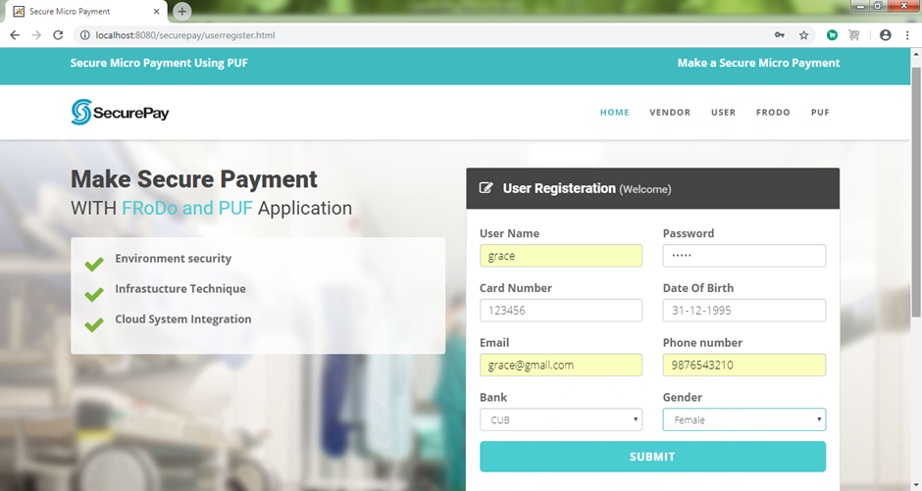

User login

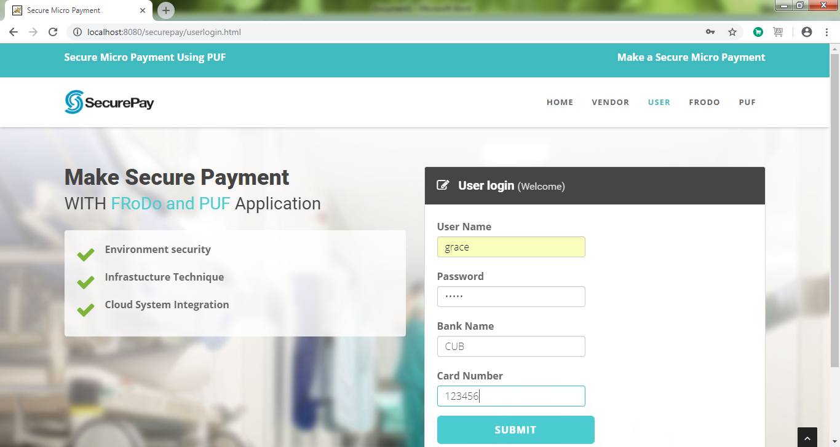

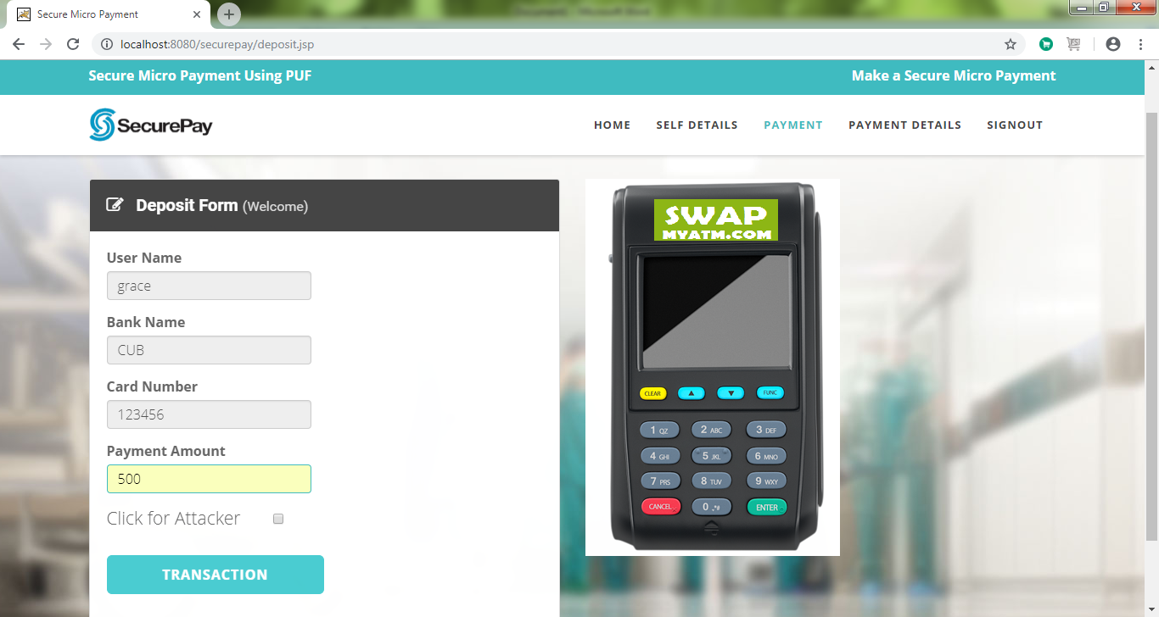

Status sending payment

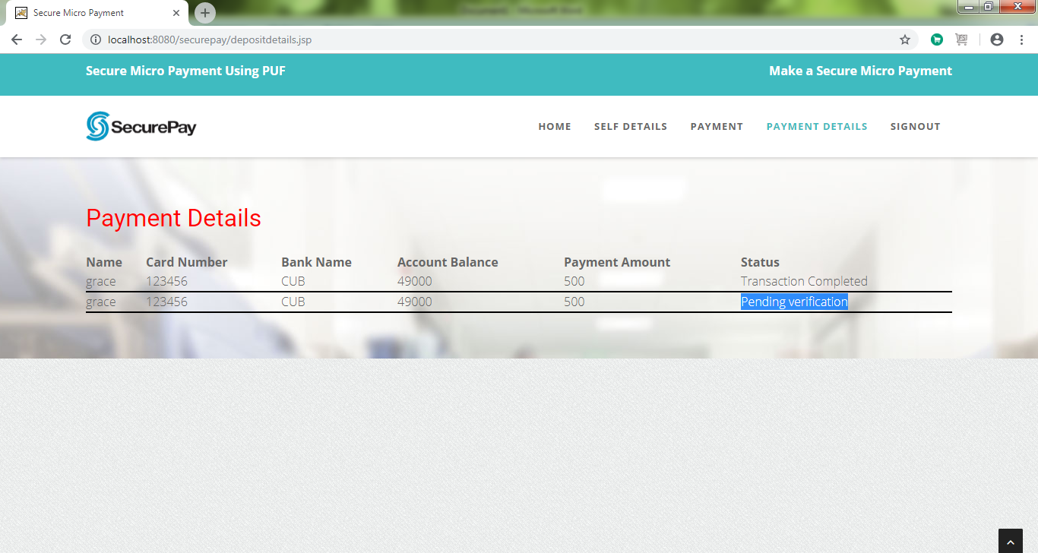

Frodo Login

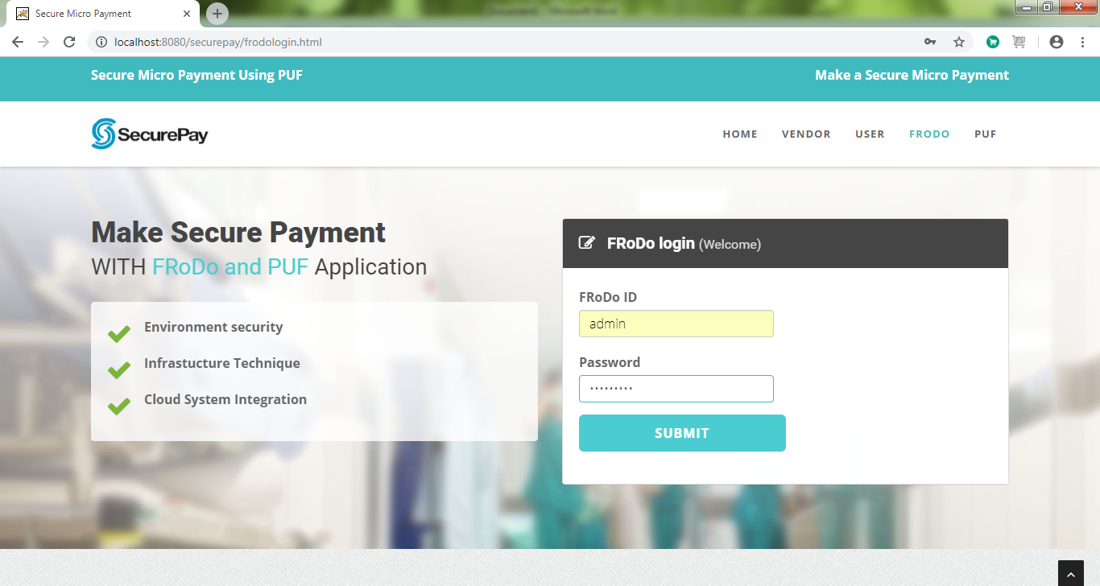

Generate user key

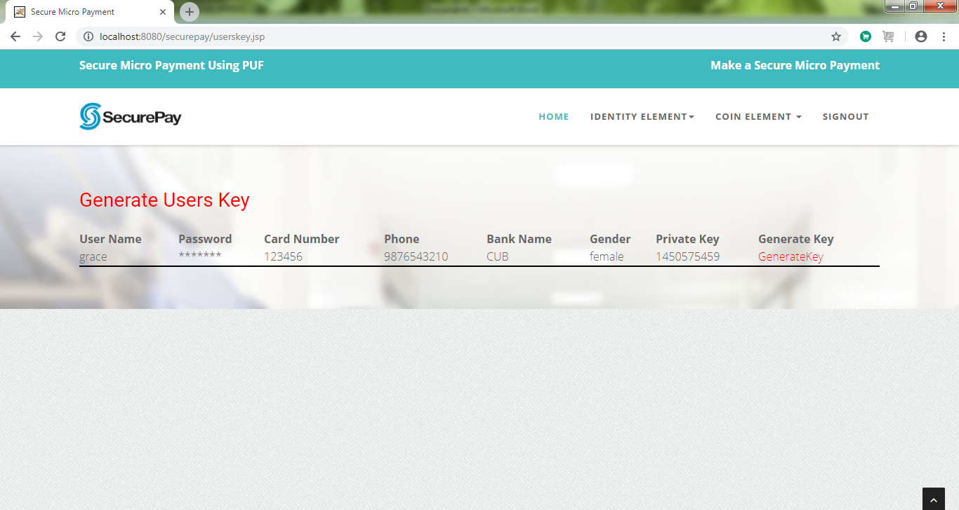

Generate Binary Number

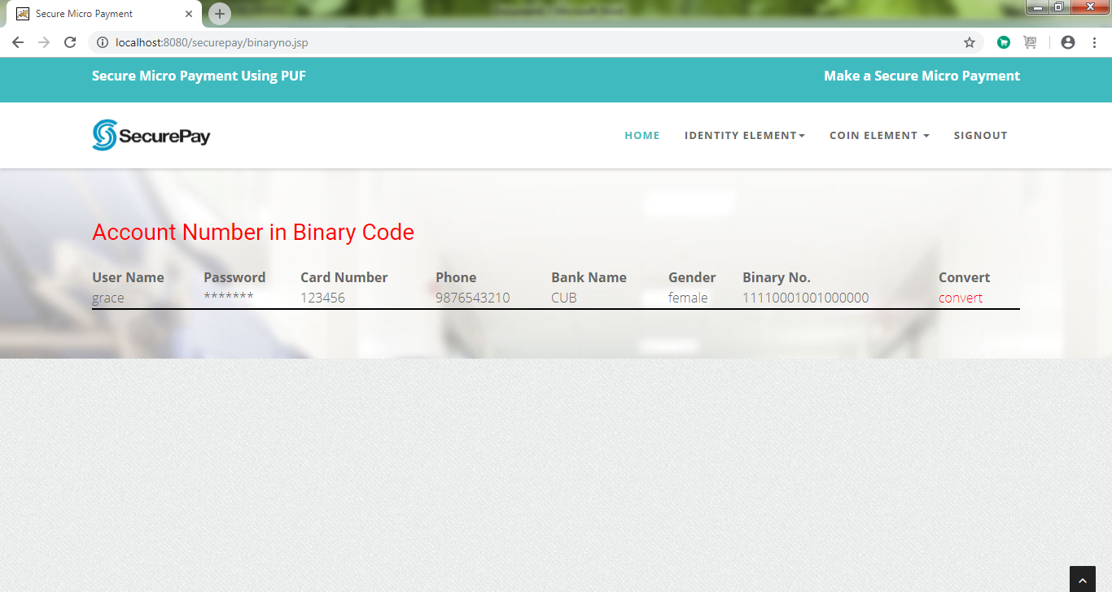

Puf Login

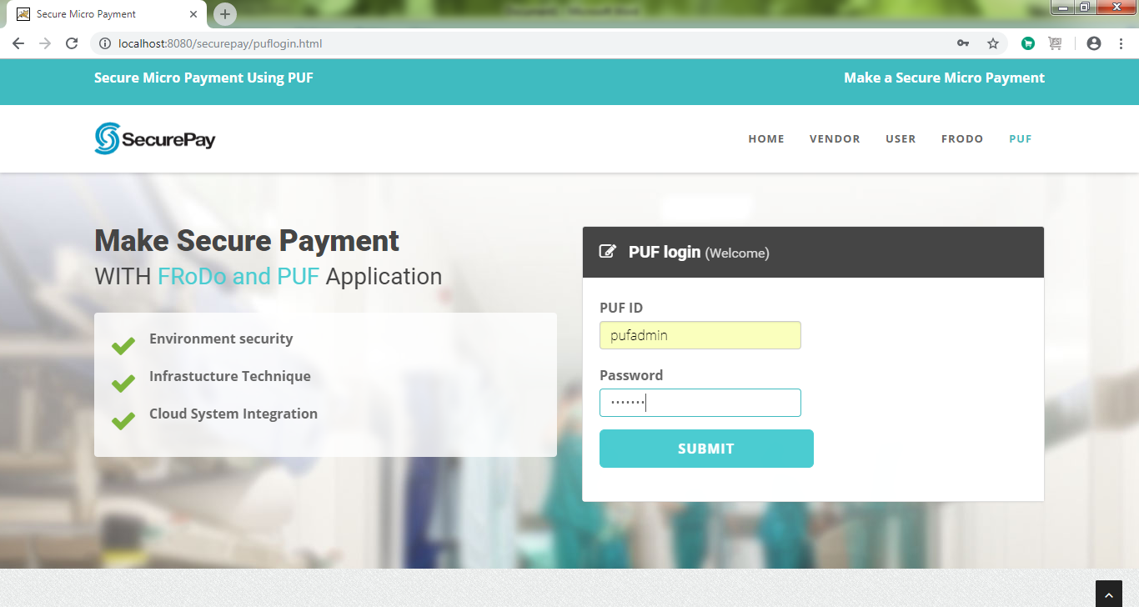

Payment Verification

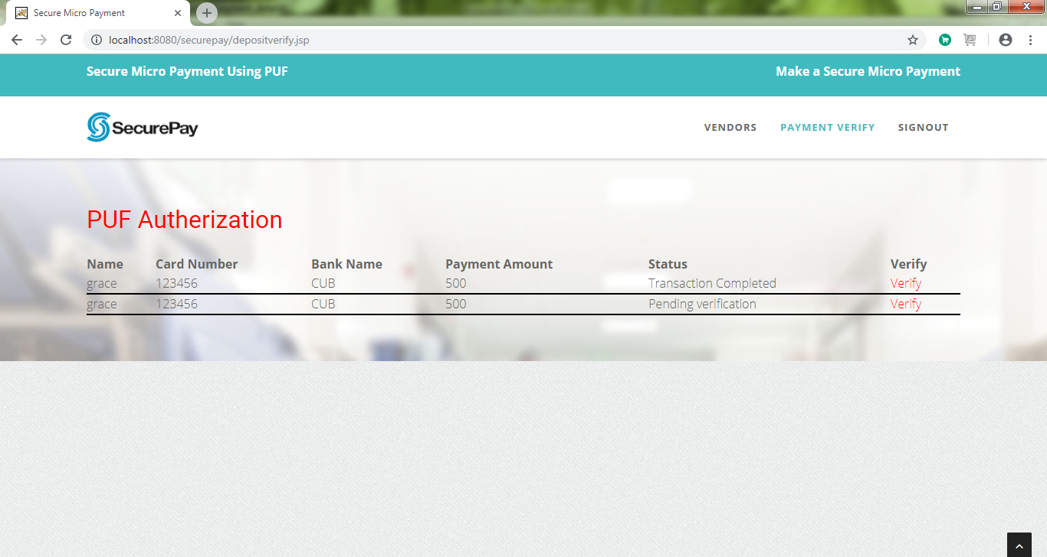

Key Verification

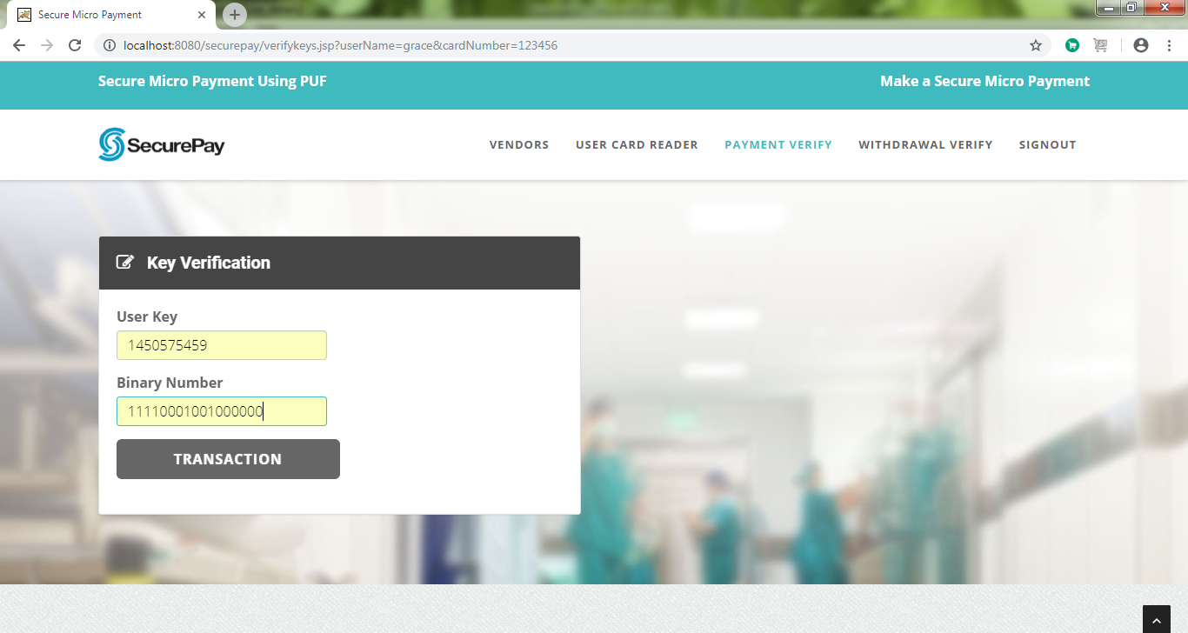

Transcation completed

